This Unity Package has Package Manager dependencies.

https://zhuanlan.zhihu.com/p/640610732

Starter Assets - ThirdPerson | Updates in new CharacterController package | 必备工具 | Unity Asset Store
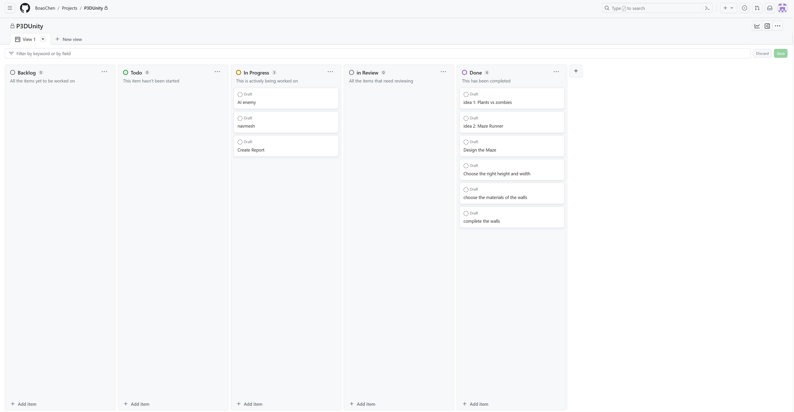
Introduction：In the future world, a colossal war erupted between humans and robots. After five years of combat, humanity ultimately faced defeat. As a member of the defeated side, you find yourself imprisoned in a complex and advanced maze. Upon waking up in a house at the center of the maze, you discover the loss of all your previous memories. Surveying the towering walls surrounding you, the only opening bears a sign prohibiting entry. As you grapple with uncertainty, tiny cameras all around focus entirely on you. Surprisingly, it wasn't the robots that triumphed over humanity; it was a minority's Human Cleansing Program. These robots haven't evolved self-awareness; they are still controlled by humans! Now, these individuals regard you as a gambling tool, monitoring your every move while placing bets on your survival time. Unbeknownst to you, this perilous maze consists of 14 levels, guarded by robots throughout. On the outermost walls, four exits are provided, and while you initially believe escaping the maze will grant you freedom, what you don't know is that these four exits represent four drastically different fates awaiting you in the future.

在未来的世界中，人类和机器人爆发了一场巨大的战争，经过五年的战斗，人类最终还是败下阵来。你作为失败方，被关进一个复杂且先进的迷宫，你从迷宫中心的房子醒来后发现自己丧失了之前的所有记忆。看了看四周都是高耸的围墙，唯一的缺口处也写着禁止进入的标语，就当你不知如何是好的时候，四周的微型摄像头正在全部聚焦到你身上。原来战胜人类的并不是机器人，而是少数人的人类清扫计划，这些机器人也并没有进化出自我意识，它们还是由人来控制的！现在这些人正把你当作赌博的工具，监视着你的一举一动纷纷在你能存活的时间上进行下注，只不过你对这一切都毫不知情。这个危机四伏的迷宫一共有14层，且到处都有机器人进行看守，最外侧的墙壁上设置了四个出口，你本以为走出这个迷宫就能获得自由，但你不知道的是，四个出口代表了你今后四种截然不同的命运。

Building：

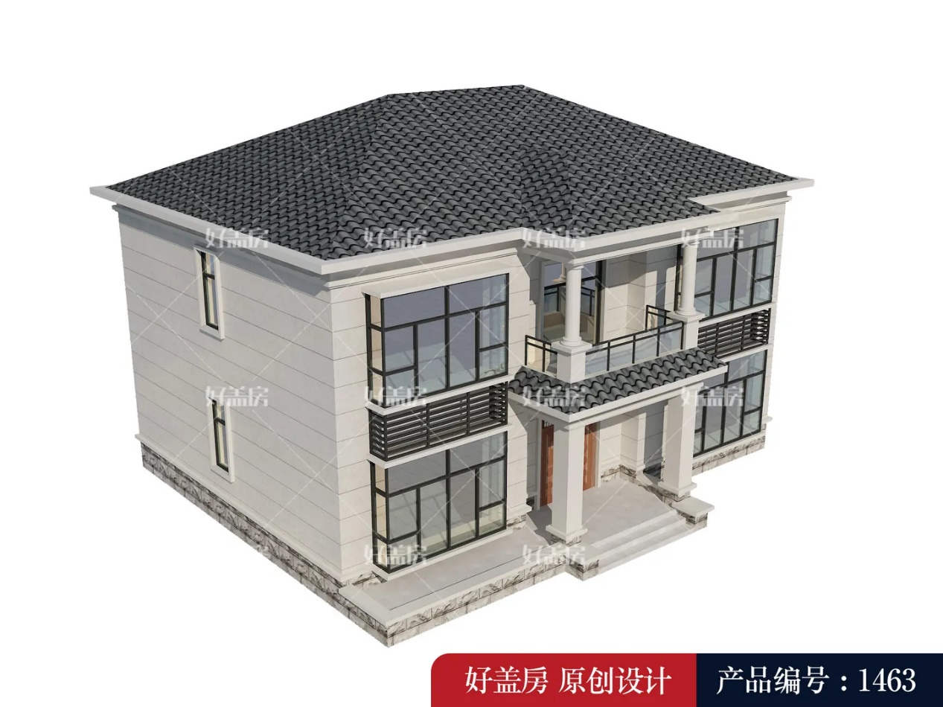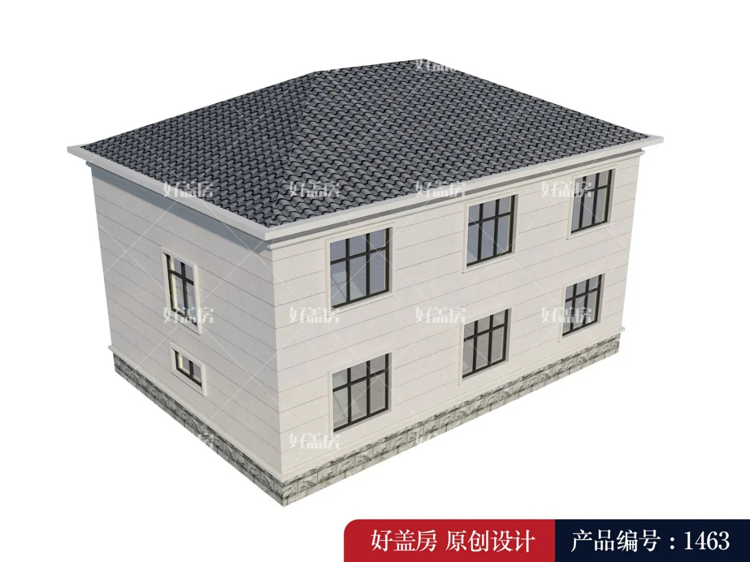
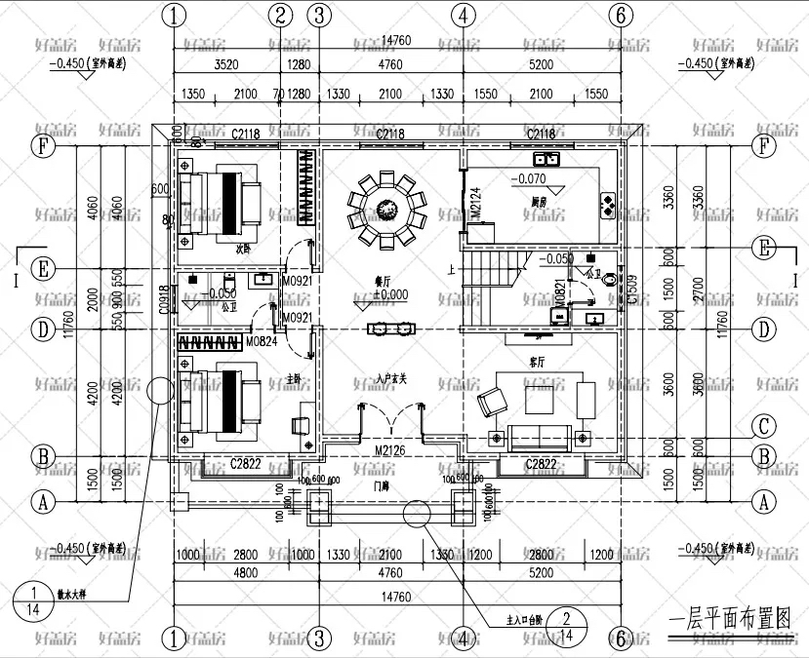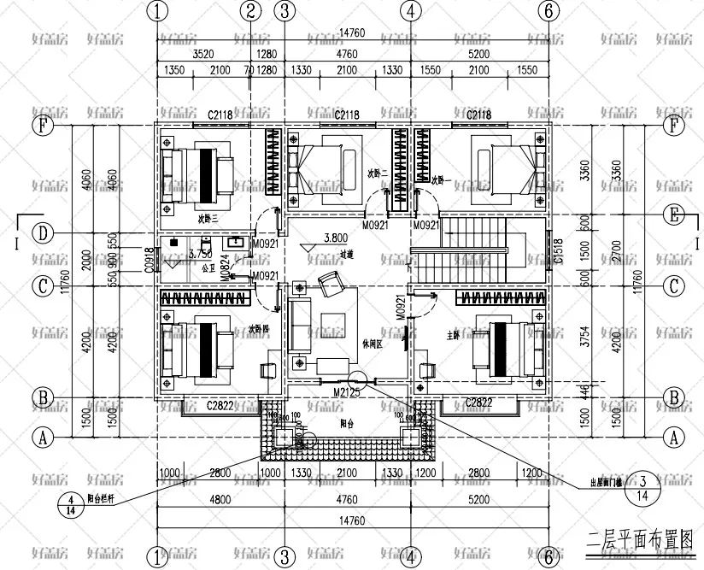Maze Design：
